Case Study

on

**DW Concept, SQL, Advance SQL**

**Case study by,**

Mouli S,

Batch – 02,

moulisankar2002@outlook.com.

**Contents**

1. Understandings of Case Study ……………………………………………3
2. Database ……………………………………………………………………………...4-7
   1. Creation ……………………………………………………………..4
   2. Insertion …………………………………………………………….5-7
3. Case Study Questions ………………………………………………………….8-14
   1. Question 1 …………………………………………………………8
   2. Question 2 …………………………………………………………9
   3. Question 3 …………………………………………………………10
   4. Question 4 …………………………………………………………11
   5. Question 5 …………………………………………………………12
   6. Question 6 …………………………………………………………13
   7. Question 7 …………………………………………………………14

**1. Understandings of Case Study**

Btech-Chai-Wala is a start-up company by Vinit and his friends. Now-a-days in the advancement of the Internet and technologies and by considering the peoples locations they decided to start online streaming services instead of the Television. So, they have created the new streaming service which will allows only the beverage related contents.

They started subscriptions like weekly, monthly and Annual. Vinit has played roles in IT sectors like Data Analyst, Enterprise Data Architect, Principal Architect etc.

This case study questions and analysis will help the start-up to investment decisions and new features to improve Btech-Chai-Wala business.

**2. Database and Tables Creation and Insertion:**

**2.1 & 2.2 Queries:**

-- Creating the database

CREATE DATABASE [btech-chai-wala];

-- Using the btech-chai-wala database

USE [btech-chai-wala];

-- Creating tables plans, subsricptions and customer

-- Creating plans table

CREATE TABLE [dbo].[plans]

(

plan_id INT NOT NULL PRIMARY KEY IDENTITY(1,1),

plan_name VARCHAR(100),

plan_price DECIMAL

);

-- Creating subscriptions table

CREATE TABLE [dbo].[subscriptions]

(

subscrip_id INT NOT NULL PRIMARY KEY IDENTITY(1,1),

cust_id INT,

plan_id INT,

start_date DATE,

is_active VARCHAR(1)

);

-- Creating customer table

CREATE TABLE [dbo].[customer]

(

cust_id INT NOT NULL PRIMARY KEY IDENTITY(1,1),

cust_name VARCHAR(100),

cust_city VARCHAR(100),

cust_dob DATE

);

-- Inserting the values into the plans, subscriptions and customer tables

--plans values

SET IDENTITY_INSERT [dbo].[plans] ON;

INSERT INTO [dbo].[plans](plan_id,plan_name,plan_price) VALUES(1,'Trail',0.00);

INSERT INTO [dbo].[plans](plan_id,plan_name,plan_price) VALUES(2,'Basic_Monthly',499.00);

INSERT INTO [dbo].[plans](plan_id,plan_name,plan_price) VALUES(3,'Pro_Monthly',999.00);

INSERT INTO [dbo].[plans](plan_id,plan_name,plan_price) VALUES(4,'Pro_Annual',11998.00);

INSERT INTO [dbo].[plans](plan_id,plan_name,plan_price) VALUES(5,'Chrun',NULL);

SET IDENTITY_INSERT [dbo].[plans] OFF;

-- subscriptions values

SET IDENTITY_INSERT [dbo].[subscriptions] ON;

INSERT INTO [dbo].[subscriptions](subscrip_id, cust_id, plan_id, start_date, is_active) VALUES(1,1,2,'2019-08-01',0);

INSERT INTO [dbo].[subscriptions](subscrip_id, cust_id, plan_id, start_date, is_active) VALUES(2,1,3,'2019-08-08',0);

INSERT INTO [dbo].[subscriptions](subscrip_id, cust_id, plan_id, start_date, is_active) VALUES(3,5,1,'2020-01-17',0);

INSERT INTO [dbo].[subscriptions](subscrip_id, cust_id, plan_id, start_date, is_active) VALUES(4,5,1,'2020-03-17',0);

INSERT INTO [dbo].[subscriptions](subscrip_id, cust_id, plan_id, start_date, is_active) VALUES(5,5,3,'2021-03-24',0);

INSERT INTO [dbo].[subscriptions](subscrip_id, cust_id, plan_id, start_date, is_active) VALUES(6,5,3,'2021-03-24',0);

INSERT INTO [dbo].[subscriptions](subscrip_id, cust_id, plan_id, start_date, is_active) VALUES(7,5,5,'2021-04-29',0);

INSERT INTO [dbo].[subscriptions](subscrip_id, cust_id, plan_id, start_date, is_active) VALUES(8,5,5,'2022-04-30',1);

INSERT INTO [dbo].[subscriptions](subscrip_id, cust_id, plan_id, start_date, is_active) VALUES(9,6,1,'2020-05-31',0);

INSERT INTO [dbo].[subscriptions](subscrip_id, cust_id, plan_id, start_date, is_active) VALUES(10,6,2,'2020-06-07',0);

INSERT INTO [dbo].[subscriptions](subscrip_id, cust_id, plan_id, start_date, is_active) VALUES(11,9,1,'2020-06-22',0);

INSERT INTO [dbo].[subscriptions](subscrip_id, cust_id, plan_id, start_date, is_active) VALUES(12,9,3,'2020-06-29',0);

INSERT INTO [dbo].[subscriptions](subscrip_id, cust_id, plan_id, start_date, is_active) VALUES(13,8,1,'2020-07-06',0);

INSERT INTO [dbo].[subscriptions](subscrip_id, cust_id, plan_id, start_date, is_active) VALUES(14,8,3,'2020-07-13',0);

INSERT INTO [dbo].[subscriptions](subscrip_id, cust_id, plan_id, start_date, is_active) VALUES(15,7,1,'2020-08-01',0);

INSERT INTO [dbo].[subscriptions](subscrip_id, cust_id, plan_id, start_date, is_active) VALUES(16,1,1,'2020-08-07',1);

INSERT INTO [dbo].[subscriptions](subscrip_id, cust_id, plan_id, start_date, is_active) VALUES(17,7,2,'2020-08-08',0);

INSERT INTO [dbo].[subscriptions](subscrip_id, cust_id, plan_id, start_date, is_active) VALUES(18,9,4,'2020-08-29',0);

INSERT INTO [dbo].[subscriptions](subscrip_id, cust_id, plan_id, start_date, is_active) VALUES(19,2,1,'2020-09-20',0);

INSERT INTO [dbo].[subscriptions](subscrip_id, cust_id, plan_id, start_date, is_active) VALUES(20,2,1,'2020-09-20',0);

INSERT INTO [dbo].[subscriptions](subscrip_id, cust_id, plan_id, start_date, is_active) VALUES(21,2,4,'2020-09-27',0);

INSERT INTO [dbo].[subscriptions](subscrip_id, cust_id, plan_id, start_date, is_active) VALUES(22,2,4,'2020-09-27',0);

INSERT INTO [dbo].[subscriptions](subscrip_id, cust_id, plan_id, start_date, is_active) VALUES(23,6,4,'2020-10-21',0);

INSERT INTO [dbo].[subscriptions](subscrip_id, cust_id, plan_id, start_date, is_active) VALUES(24,2,1,'2020-11-19',0);

INSERT INTO [dbo].[subscriptions](subscrip_id, cust_id, plan_id, start_date, is_active) VALUES(25,10,1,'2020-11-19',0);

INSERT INTO [dbo].[subscriptions](subscrip_id, cust_id, plan_id, start_date, is_active) VALUES(26,2,5,'2020-11-26',1);

INSERT INTO [dbo].[subscriptions](subscrip_id, cust_id, plan_id, start_date, is_active) VALUES(27,10,5,'2021-11-26',1);

INSERT INTO [dbo].[subscriptions](subscrip_id, cust_id, plan_id, start_date, is_active) VALUES(28,3,1,'2020-12-15',0);

INSERT INTO [dbo].[subscriptions](subscrip_id, cust_id, plan_id, start_date, is_active) VALUES(29,3,1,'2020-12-15',0);

INSERT INTO [dbo].[subscriptions](subscrip_id, cust_id, plan_id, start_date, is_active) VALUES(30,3,2,'2020-12-22',0);

INSERT INTO [dbo].[subscriptions](subscrip_id, cust_id, plan_id, start_date, is_active) VALUES(31,4,2,'2020-12-22',0);

INSERT INTO [dbo].[subscriptions](subscrip_id, cust_id, plan_id, start_date, is_active) VALUES(32,4,3,'2021-03-29',1);

INSERT INTO [dbo].[subscriptions](subscrip_id, cust_id, plan_id, start_date, is_active) VALUES(33,3,3,'2021-03-29',1);

INSERT INTO [dbo].[subscriptions](subscrip_id, cust_id, plan_id, start_date, is_active) VALUES(34,6,1,'2021-05-31',0);

INSERT INTO [dbo].[subscriptions](subscrip_id, cust_id, plan_id, start_date, is_active) VALUES(35,6,2,'2021-06-07',0);

INSERT INTO [dbo].[subscriptions](subscrip_id, cust_id, plan_id, start_date, is_active) VALUES(36,9,1,'2021-06-22',0);

INSERT INTO [dbo].[subscriptions](subscrip_id, cust_id, plan_id, start_date, is_active) VALUES(37,9,3,'2021-06-29',0);

INSERT INTO [dbo].[subscriptions](subscrip_id, cust_id, plan_id, start_date, is_active) VALUES(38,8,1,'2021-07-06',0);

INSERT INTO [dbo].[subscriptions](subscrip_id, cust_id, plan_id, start_date, is_active) VALUES(39,8,3,'2021-07-13',1);

INSERT INTO [dbo].[subscriptions](subscrip_id, cust_id, plan_id, start_date, is_active) VALUES(40,7,1,'2021-08-01',1);

INSERT INTO [dbo].[subscriptions](subscrip_id, cust_id, plan_id, start_date, is_active) VALUES(41,9,4,'2022-08-29',1);

INSERT INTO [dbo].[subscriptions](subscrip_id, cust_id, plan_id, start_date, is_active) VALUES(42,6,4,'2021-10-21',1);

SET IDENTITY_INSERT [dbo].[subscriptions] OFF;

-- customer values

SET IDENTITY_INSERT [dbo].[customer] ON;

INSERT INTO [dbo].[customer](cust_id, cust_name, cust_city, cust_dob) VALUES(1,'Chaitanya','Bangalore', 2001-02-02');

INSERT INTO [dbo].[customer](cust_id, cust_name, cust_city, cust_dob) VALUES(2,'Harini','Mumbai', ‘2001-07-19’);

INSERT INTO [dbo].[customer](cust_id, cust_name, cust_city, cust_dob) VALUES(3,'Indu','Chennai', '2001-01-21');

INSERT INTO [dbo].[customer](cust_id, cust_name, cust_city, cust_dob) VALUES(4,'Jameela','Hyderabad', '2002-05-01');

INSERT INTO [dbo].[customer](cust_id, cust_name, cust_city, cust_dob) VALUES(5,'Neeha','Bangalore', '2000-03-15');

INSERT INTO [dbo].[customer](cust_id, cust_name, cust_city, cust_dob) VALUES(6,'Reshma','Mumbai', '2001-02-02');

INSERT INTO [dbo].[customer](cust_id, cust_name, cust_city, cust_dob) VALUES(7,'Sahithi','Chennai', '2000-11-02');

INSERT INTO [dbo].[customer](cust_id, cust_name, cust_city, cust_dob) VALUES(8,'Sharmila','Hyderabad', '2001-04-22');

INSERT INTO [dbo].[customer](cust_id, cust_name, cust_city, cust_dob) VALUES(9,'Sreelakshmi','Bangalore', '2000-06-17');

INSERT INTO [dbo].[customer](cust_id, cust_name, cust_city, cust_dob) VALUES(10,'Subasri','Mumbai', '2002-01-30');

SET IDENTITY_INSERT [dbo].[customer] OFF;

-- Verifying the values inserted properly

SELECT * FROM [dbo].[plans];

SELECT * FROM [dbo].[subscriptions];

SELECT * FROM [dbo].[customer];

**Screenshots:**

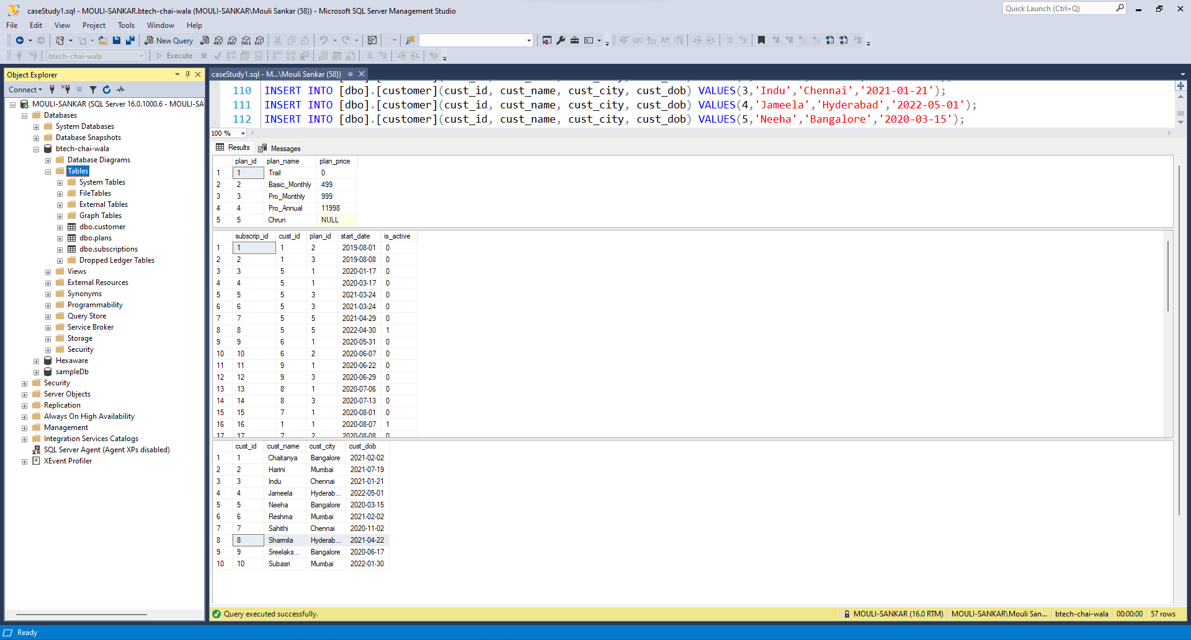

**3. Case Study Questions**

**3.1 Question 1**

**Summarize your understanding of Section 01 of this document is less than 60 words.**

Btech-Chai-Wala is a start-up company which will allows only the beverage related contents. In the advancement of the Internet and technologies and by considering the peoples locations they decided to start streaming services instead of the Television. So, started streaming service.

They started weekly, monthly and Annual subscriptions. Vinit has played roles in IT sectors need to help him to improve business.

**3.2 Question 2**

**Based on the 10 customers provided in the section 2.4 of this document refer subscriptions & customer table, customers having age 21 as of date get their onboarding dates.**

**Query:**

SELECT c.cust_id,

c.cust_name,

c.cust_city,

p.plan_name,

p.plan_price,

s.start_date,

s.is_active

FROM [dbo].[customer] c

INNER JOIN [dbo].[subscriptions] s ON c.cust_id = s.cust_id

INNER JOIN [dbo].[plans] p ON s.plan_id = p.plan_id

WHERE DATEDIFF(YEAR, c.cust_dob, GETDATE()) = 21 AND s.is_active = 1

GROUP BY c.cust_id, c.cust_name, c.cust_city, p.plan_name, p.plan_price, s.start_date, s.is_active;

**Screenshot:**

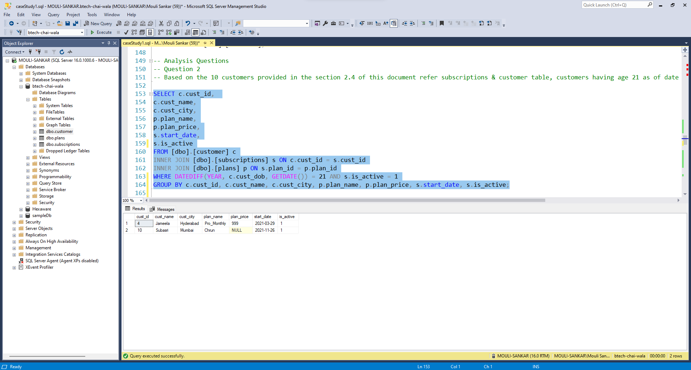

**3.3 Question 3**

**How many customers has BTe ch-Chai-Wala with activate subscription as on 5 th May 2021?**

**Query:**

SELECT COUNT(DISTINCT c.cust_id) AS 'Count of Customers'

FROM [dbo].[customer] c

INNER JOIN [dbo].[subscriptions] s ON c.cust_id = s.cust_id

WHERE s.is_active = 1 AND s.start_date <= '2021-05-05' AND s.start_date >= '2021-05-05';

**Screenshot:**

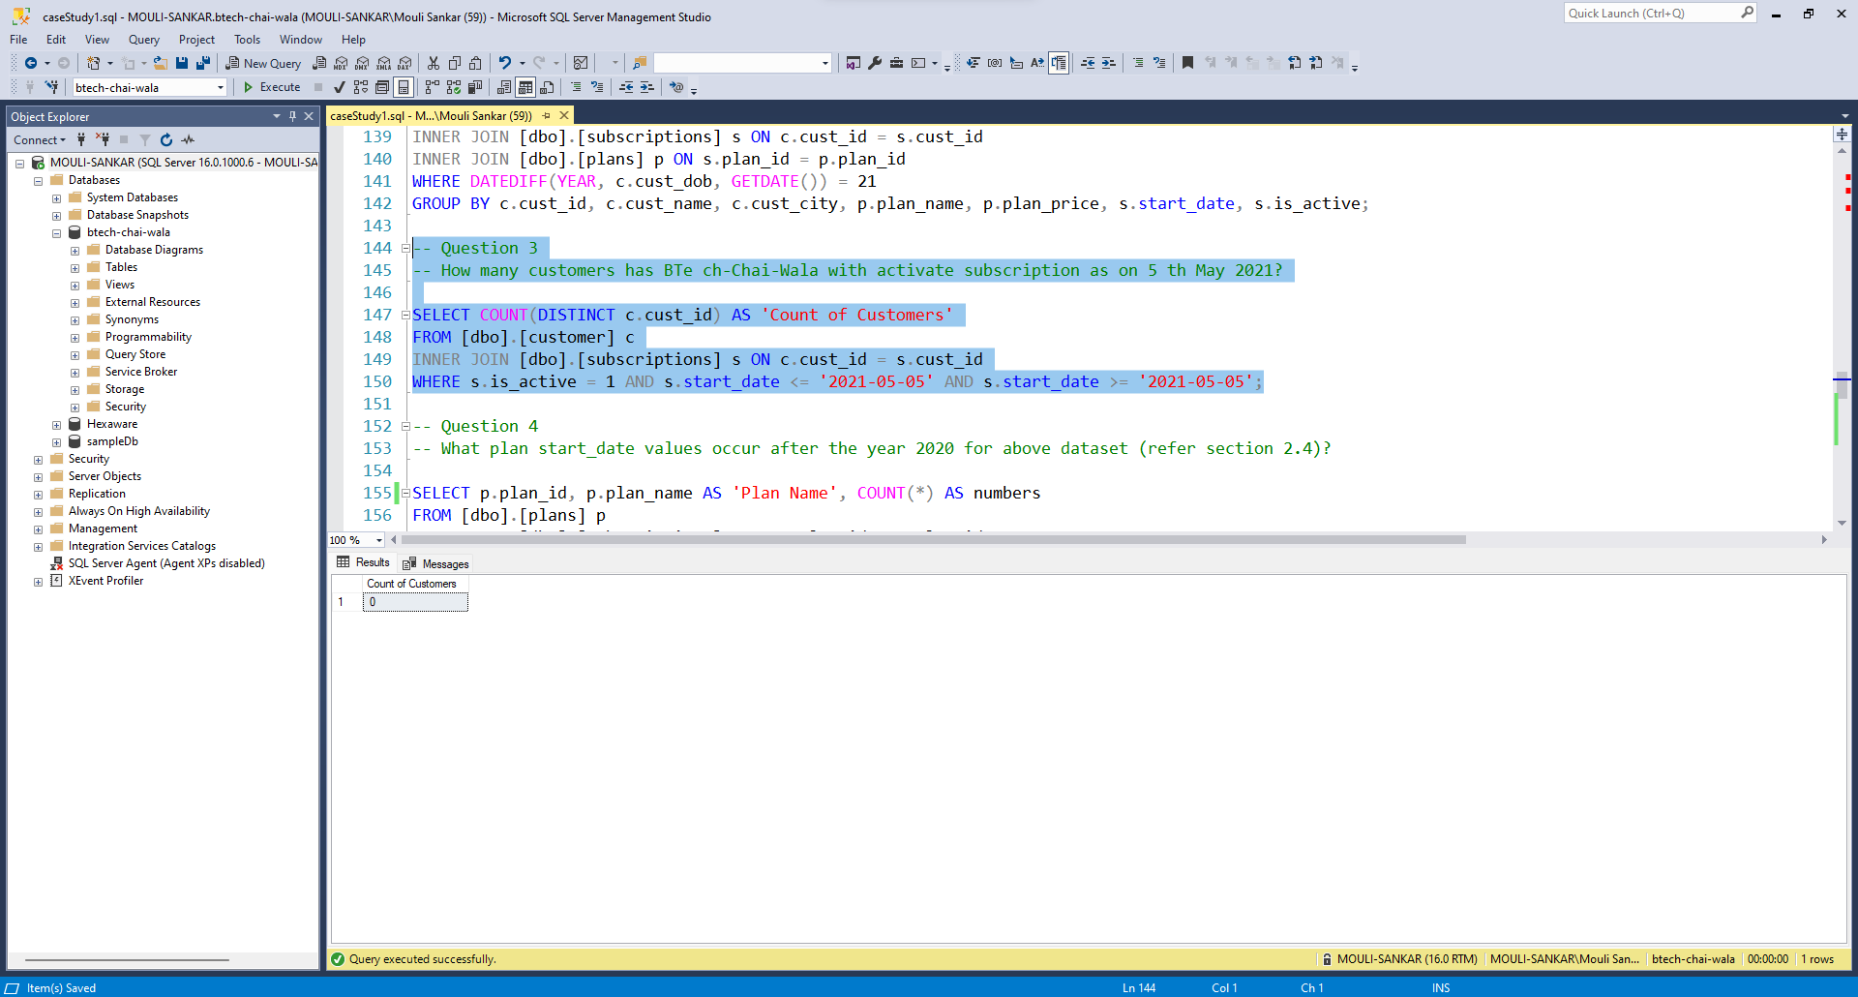

**3.4 Question 4**

**What plan start_date values occur after the year 2020 for above dataset (refer section 2.4)?**

**Query:**

SELECT p.plan_id, p.plan_name AS 'Plan Name', COUNT(*) AS numbers

FROM [dbo].[plans] p

INNER JOIN [dbo].[subscriptions] s ON p.plan_id = s.plan_id

WHERE YEAR(s.start_date) > '2020'

GROUP BY p.plan_id, p.plan_name;

**Screenshot:**

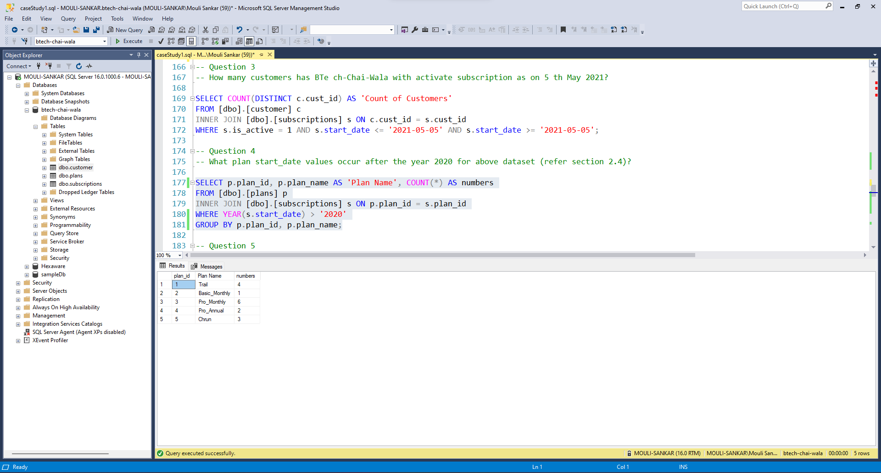

**3.5 Question 5**

**What is the customer count and percentage breakdown of all 5 plan_name values at 2020-12-31?**

**Query:**

WITH customers_next_plan AS(

SELECT cust_id, plan_id, start_date,

LEAD(start_date, 1) OVER(PARTITION BY cust_id ORDER BY start_date) as customers_next_date

FROM [dbo].[subscriptions]

WHERE start_date <= '2020-12-31'),

customer_brkdown AS (

SELECT plan_id, COUNT(DISTINCT cust_id) AS customers

FROM customers_next_plan

WHERE (customers_next_date IS NOT NULL AND (start_date < '2020-12-31' AND customers_next_date > '2020-12-31'))

OR (customers_next_date IS NULL AND start_date < '2020-12-31')

GROUP BY plan_id)

SELECT plan_id,customers ,

ROUND(100 * CAST(customers AS NUMERIC) / (

SELECT COUNT(DISTINCT cust_id)

FROM [dbo].[subscriptions]),1) AS percentage

FROM customer_brkdown

GROUP BY plan_id, customers

ORDER BY plan_id;

**Screenshot:**

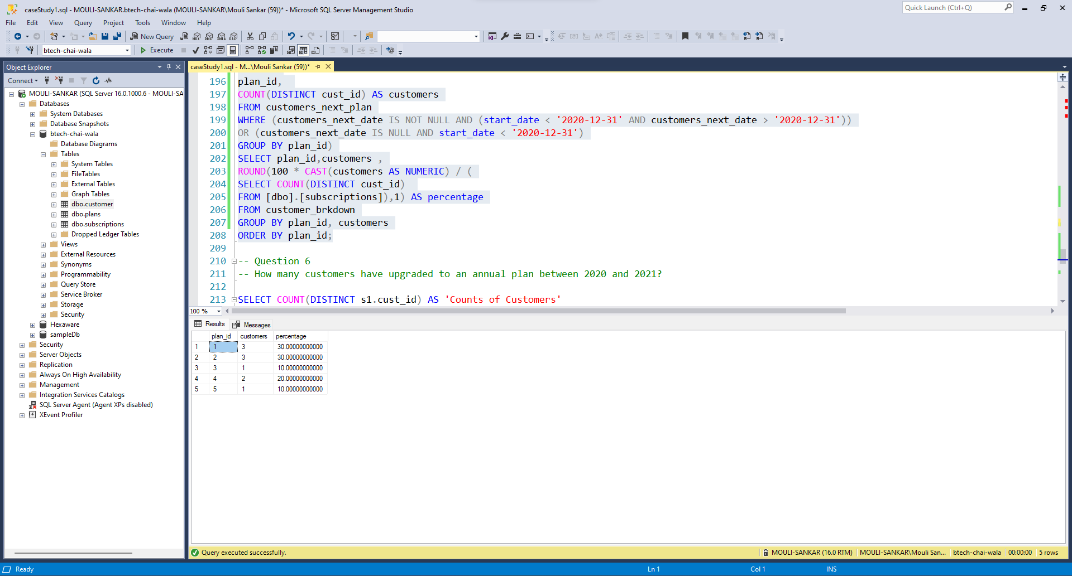

**3.6 Question 6**

**How many customers have upgraded to an annual plan between 2020 and 2021?**

**Query:**

SELECT COUNT(DISTINCT s1.cust_id) AS 'Counts of Customers'

FROM [dbo].[subscriptions] s1

INNER JOIN [dbo].[subscriptions] s2 ON s1.cust_id = s2.cust_id

INNER JOIN [dbo].[plans] p ON s1.plan_id = p.plan_id

WHERE s1.plan_id != s2.plan_id

AND YEAR(s1.start_date) >= '2020' AND YEAR(s2.start_date) <= '2021'

AND p.plan_name = 'Pro_Annual';

**Screenshot:**

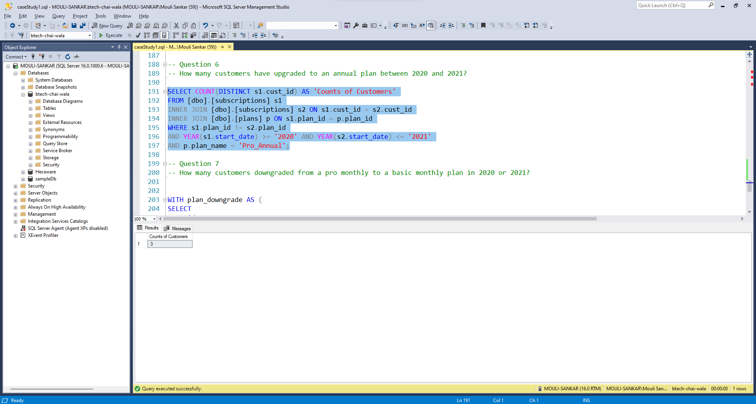

**3.7 Question 7**

**How many customers downgraded from a pro monthly to a basic monthly plan in 2020 or 2021?**

**Query:**

WITH plan_downgrade AS (

SELECT

cust_id,

plan_id,

start_date,

LEAD(plan_id, 1) OVER(PARTITION BY cust_id ORDER BY plan_id) AS down_plan

FROM [dbo].[subscriptions])

SELECT COUNT(*) AS 'Number of Customers Downgraded'

FROM plan_downgrade

WHERE start_date <= '2020-12-31' AND plan_id = 2 AND down_plan = 1;

**Screenshot:**

